CSC CA2

ASSIGNMENT SUBMISSION

DOCUMENTATION

Name: So Wei Hao P1843059

Technology Stack

Amazon EC2

Used to host the web app

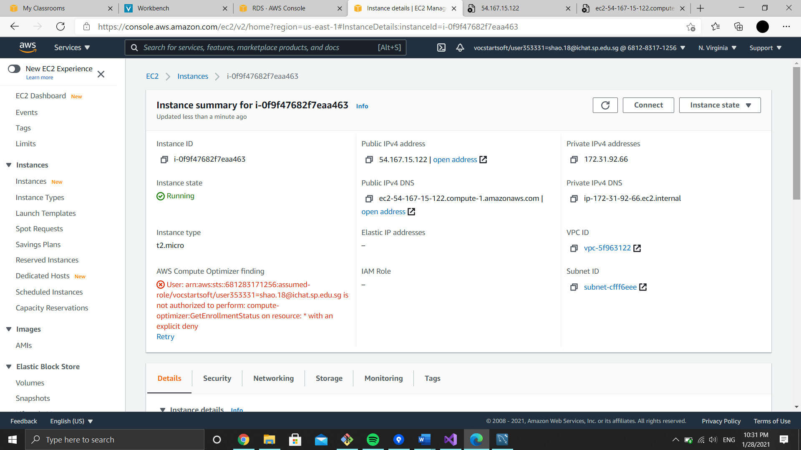

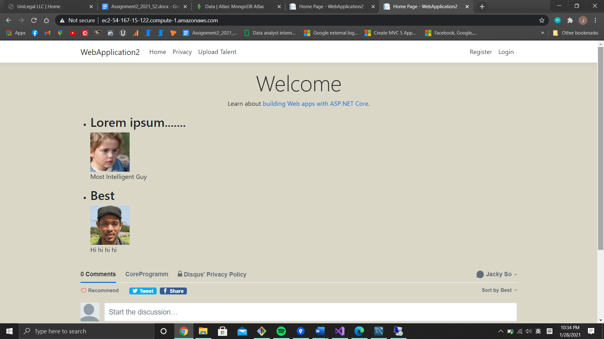

Stripe Subscription

Used to let user subscribe to free plan or premium plan

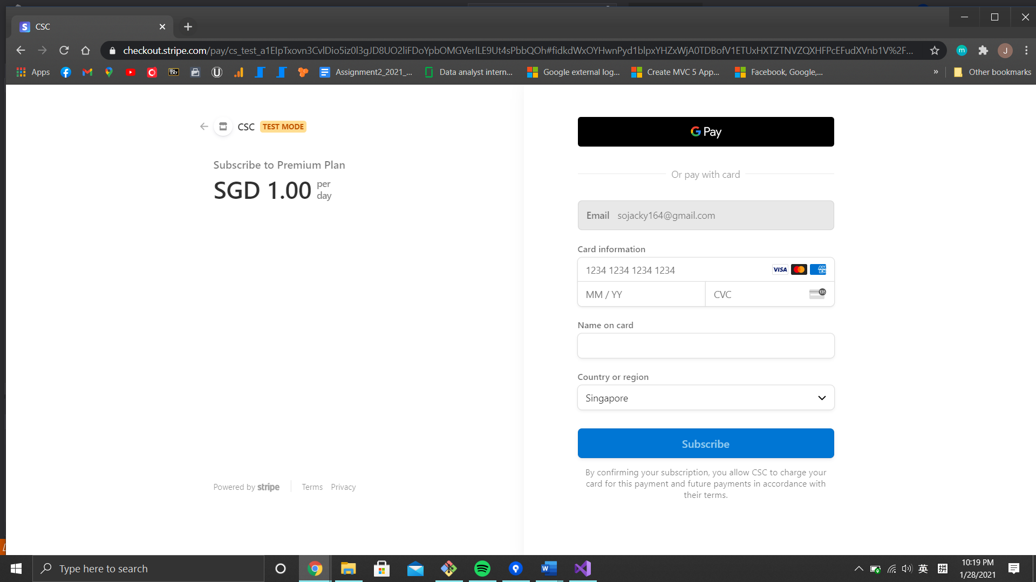

Disqus

Allow user to comment

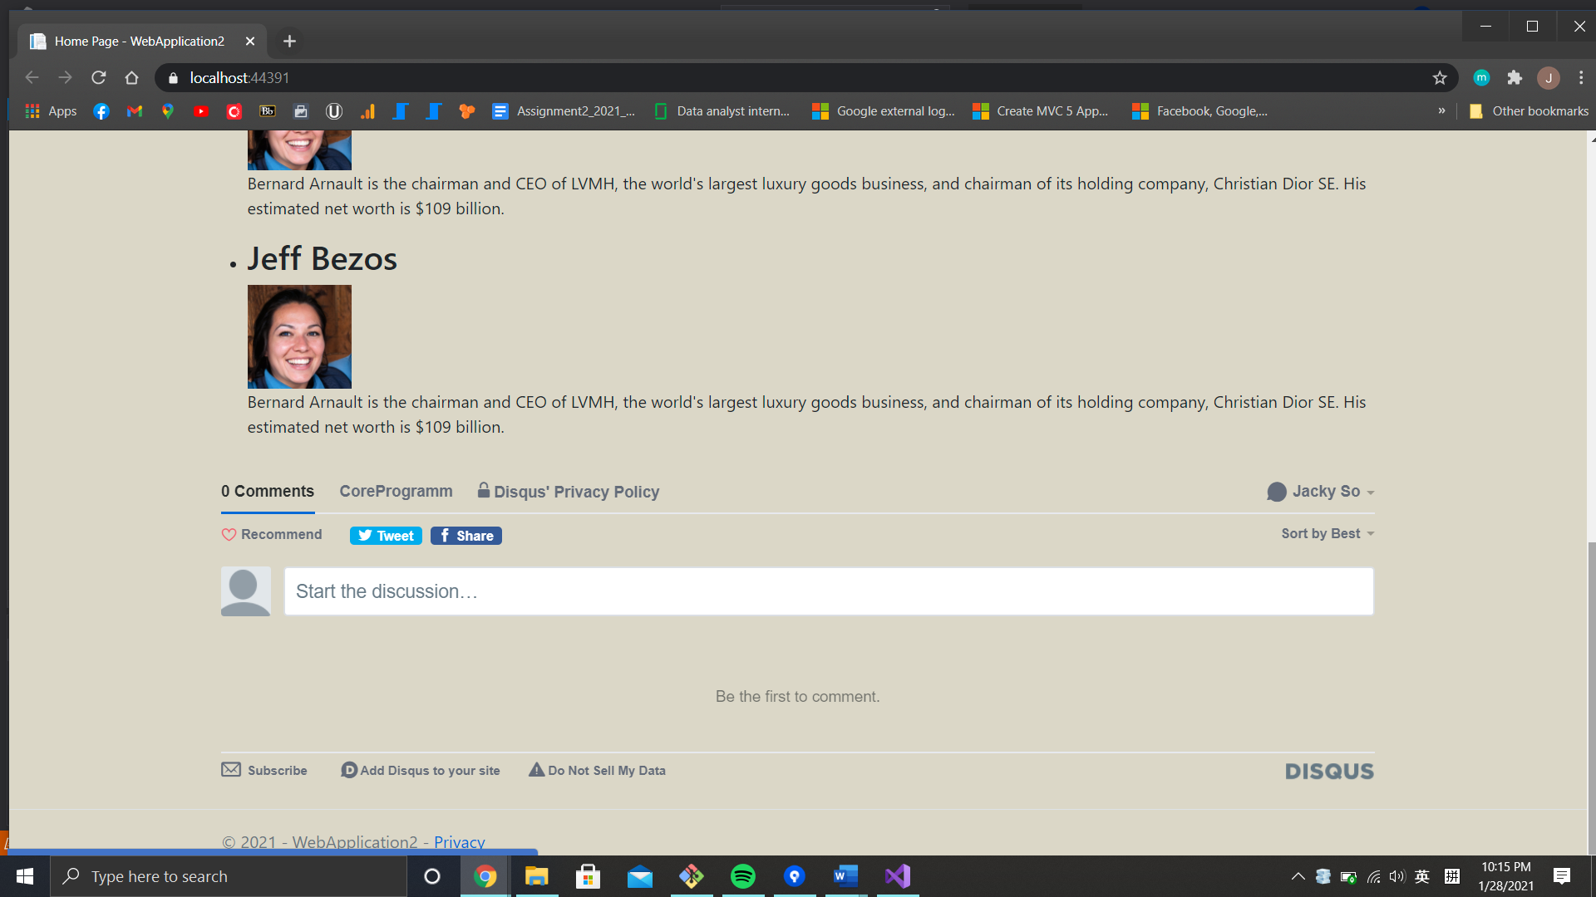

Amazon S3

Bucket to allow user to upload talent’s photo

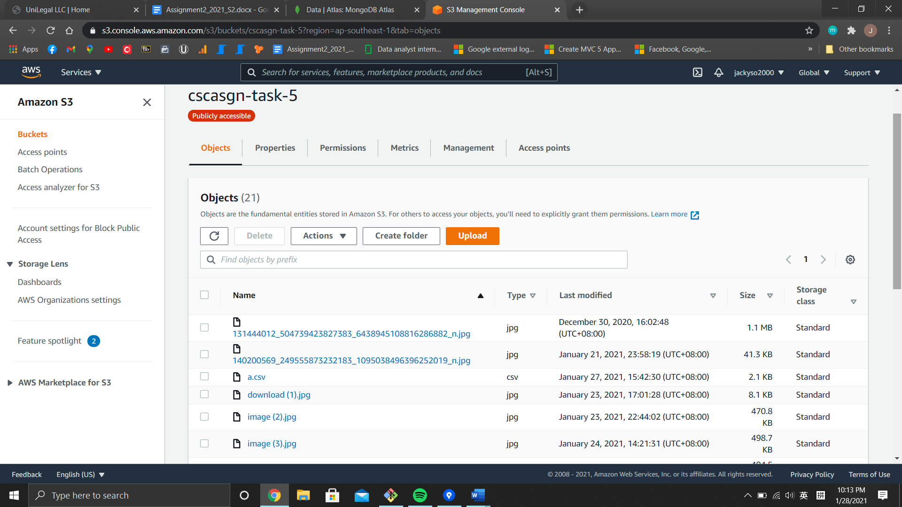

Clarifai

Used the OCR recognition AI to determine whether the uploaded images contains a human face

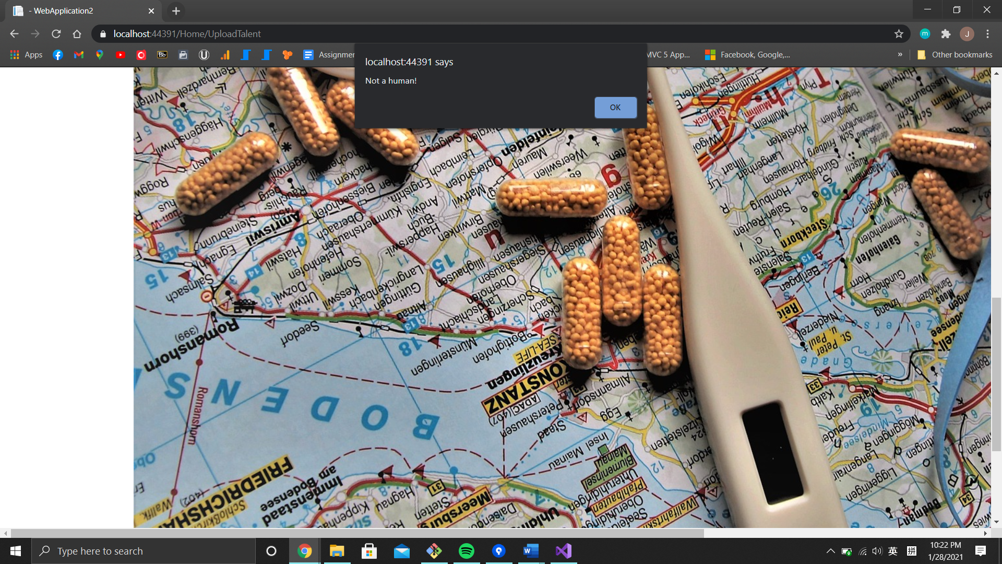

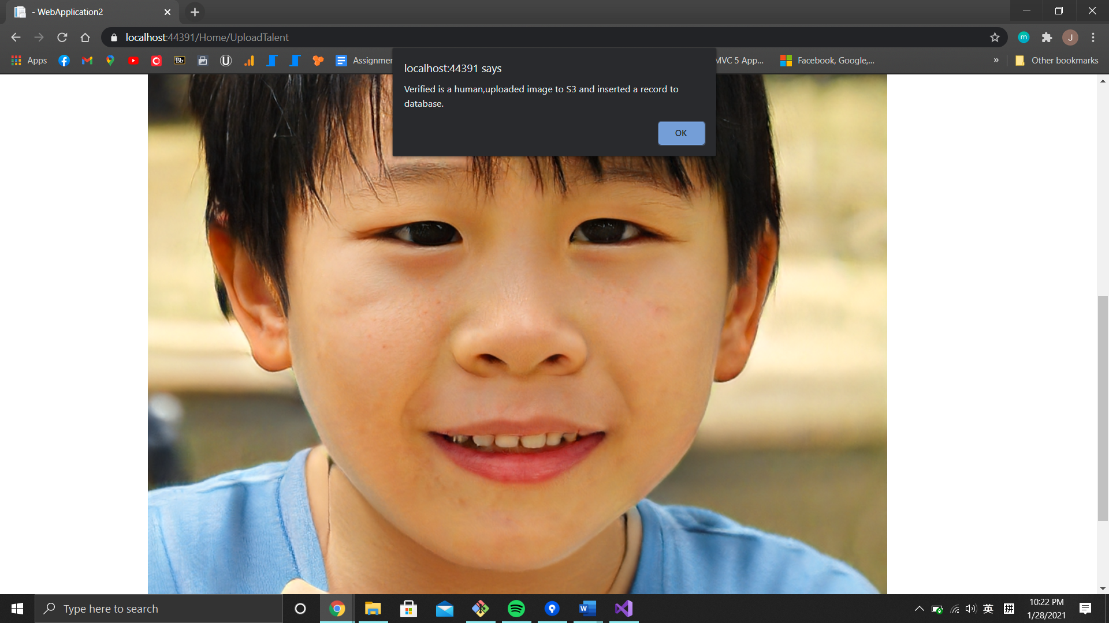

Amazon RDS

SQL Database used to store talents’ details such as image URL, name, short name, reknown, bio and id.

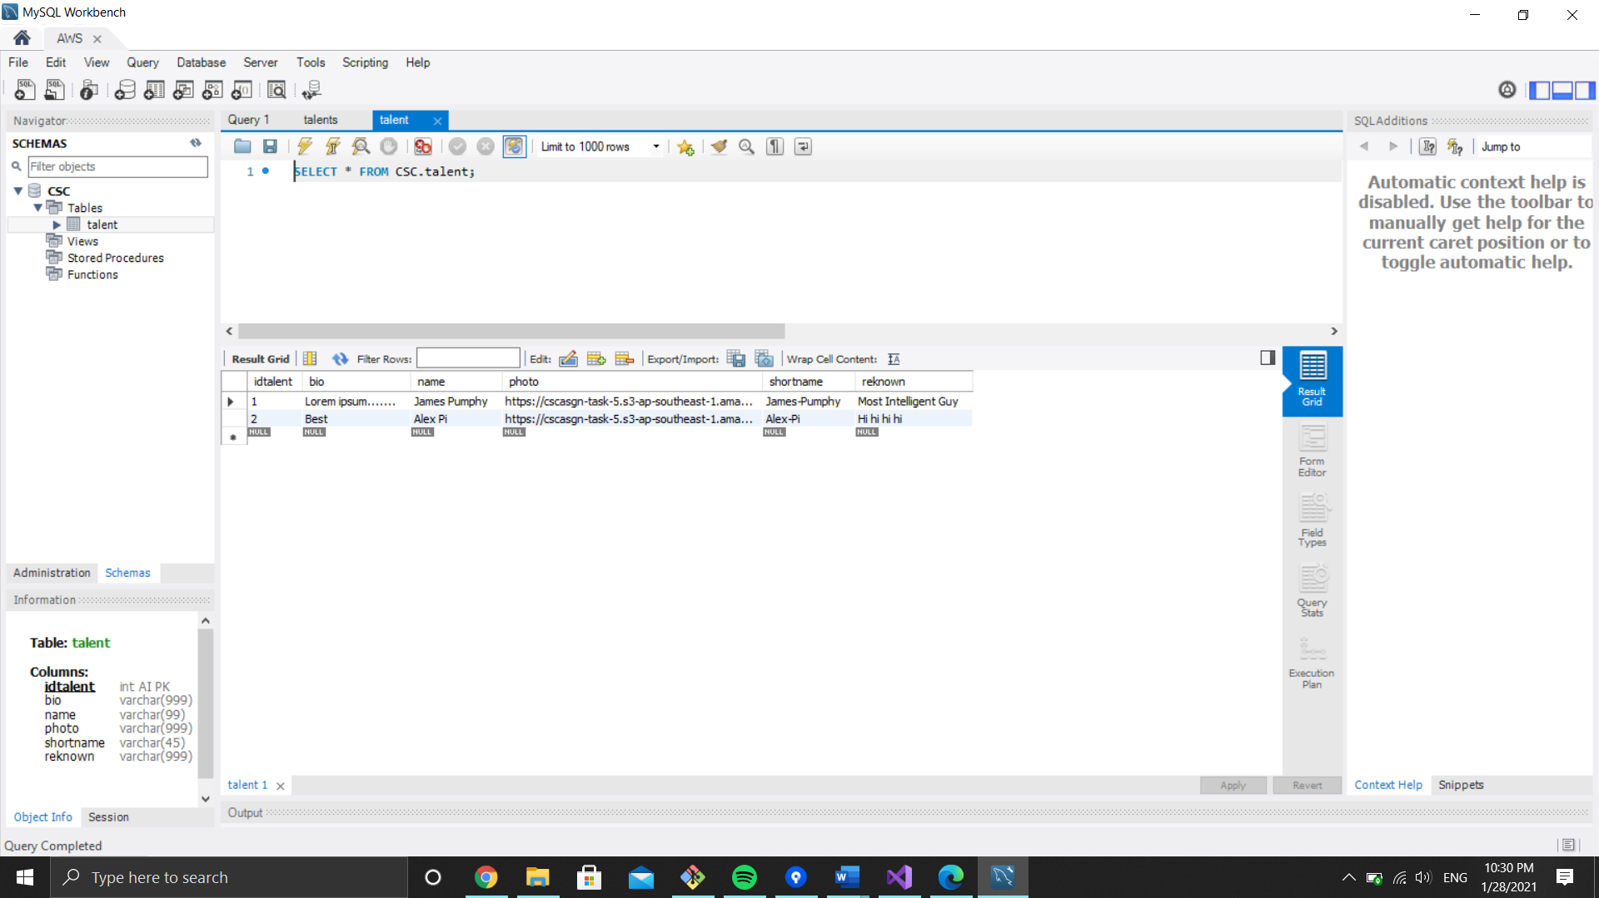

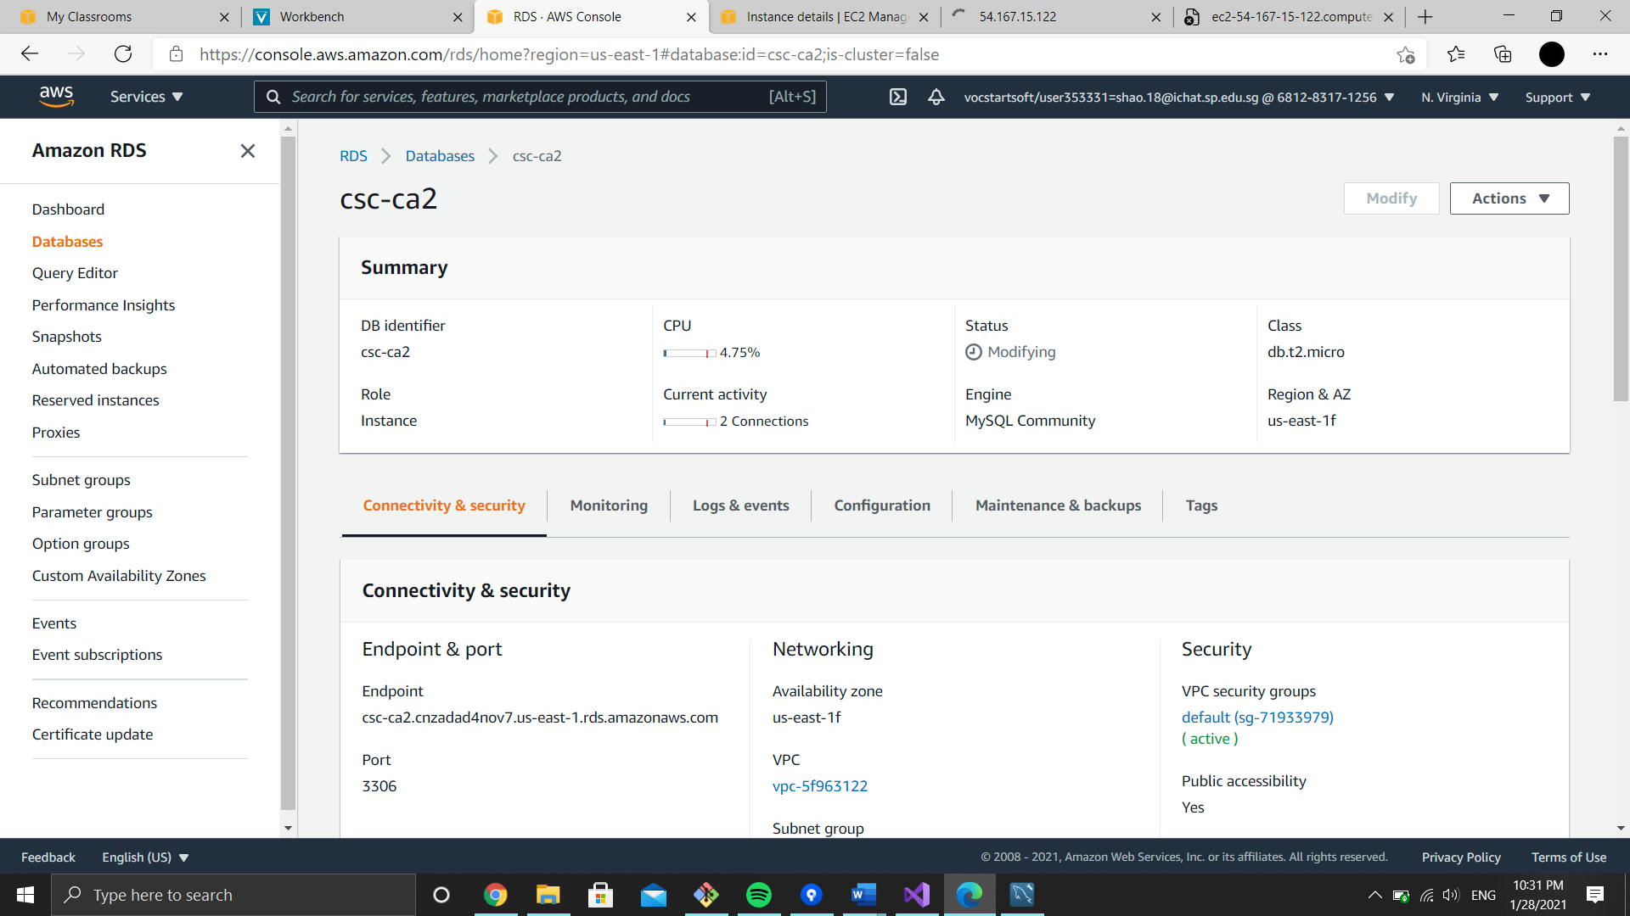

MongoDB

NoSQL Database used to store user details such as id, email, subscription id, plan subscribed and last paid date.

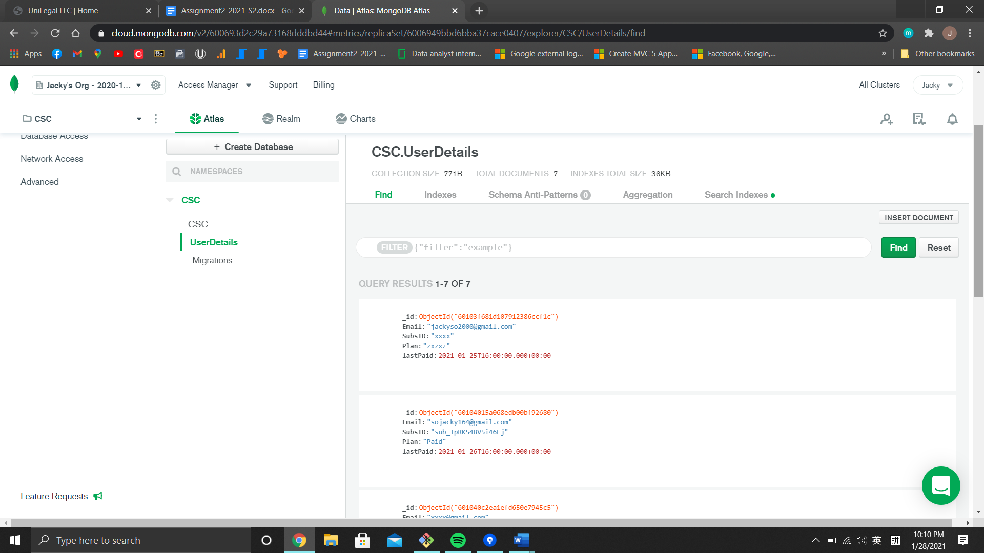

Amazon Redshift

Used to import data from databases via csv files for future Business Intelligence

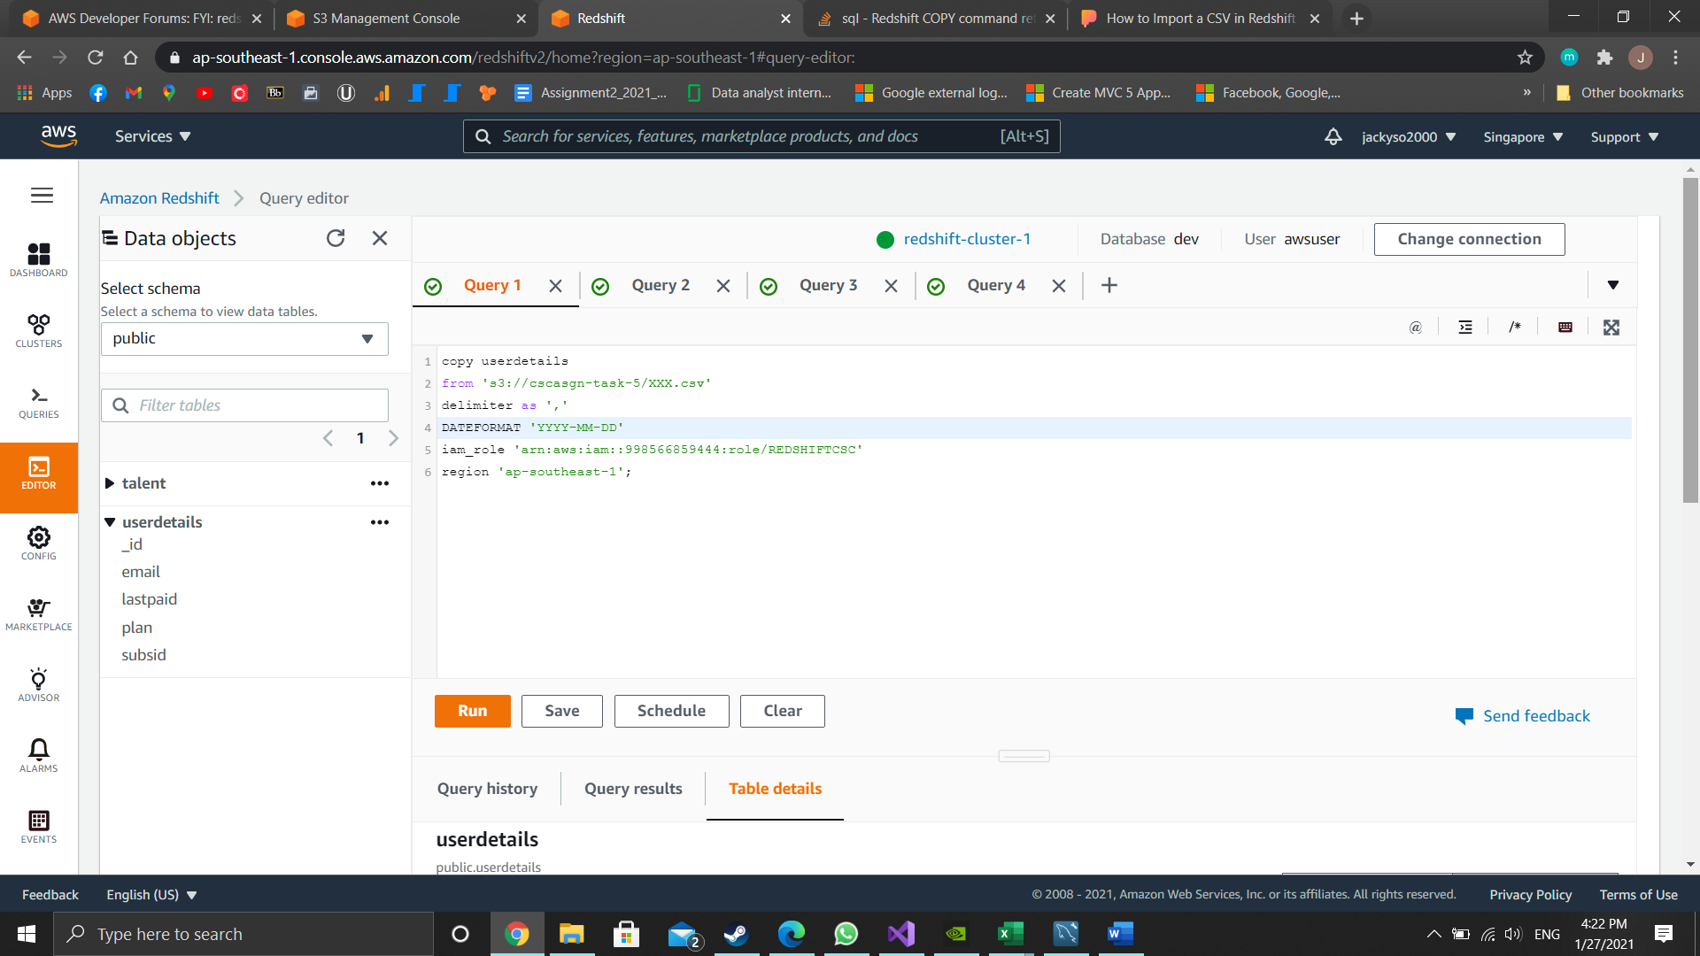

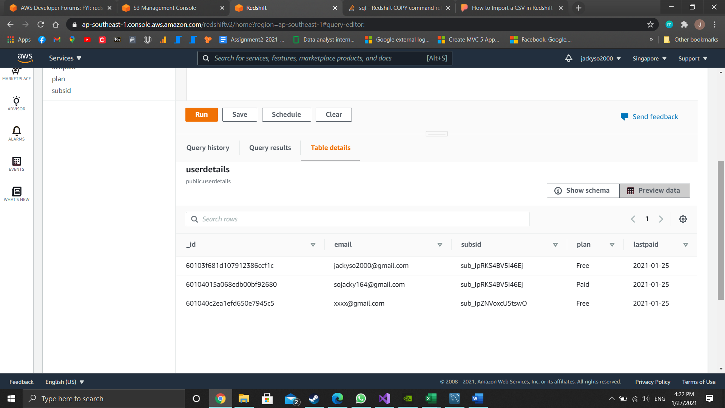

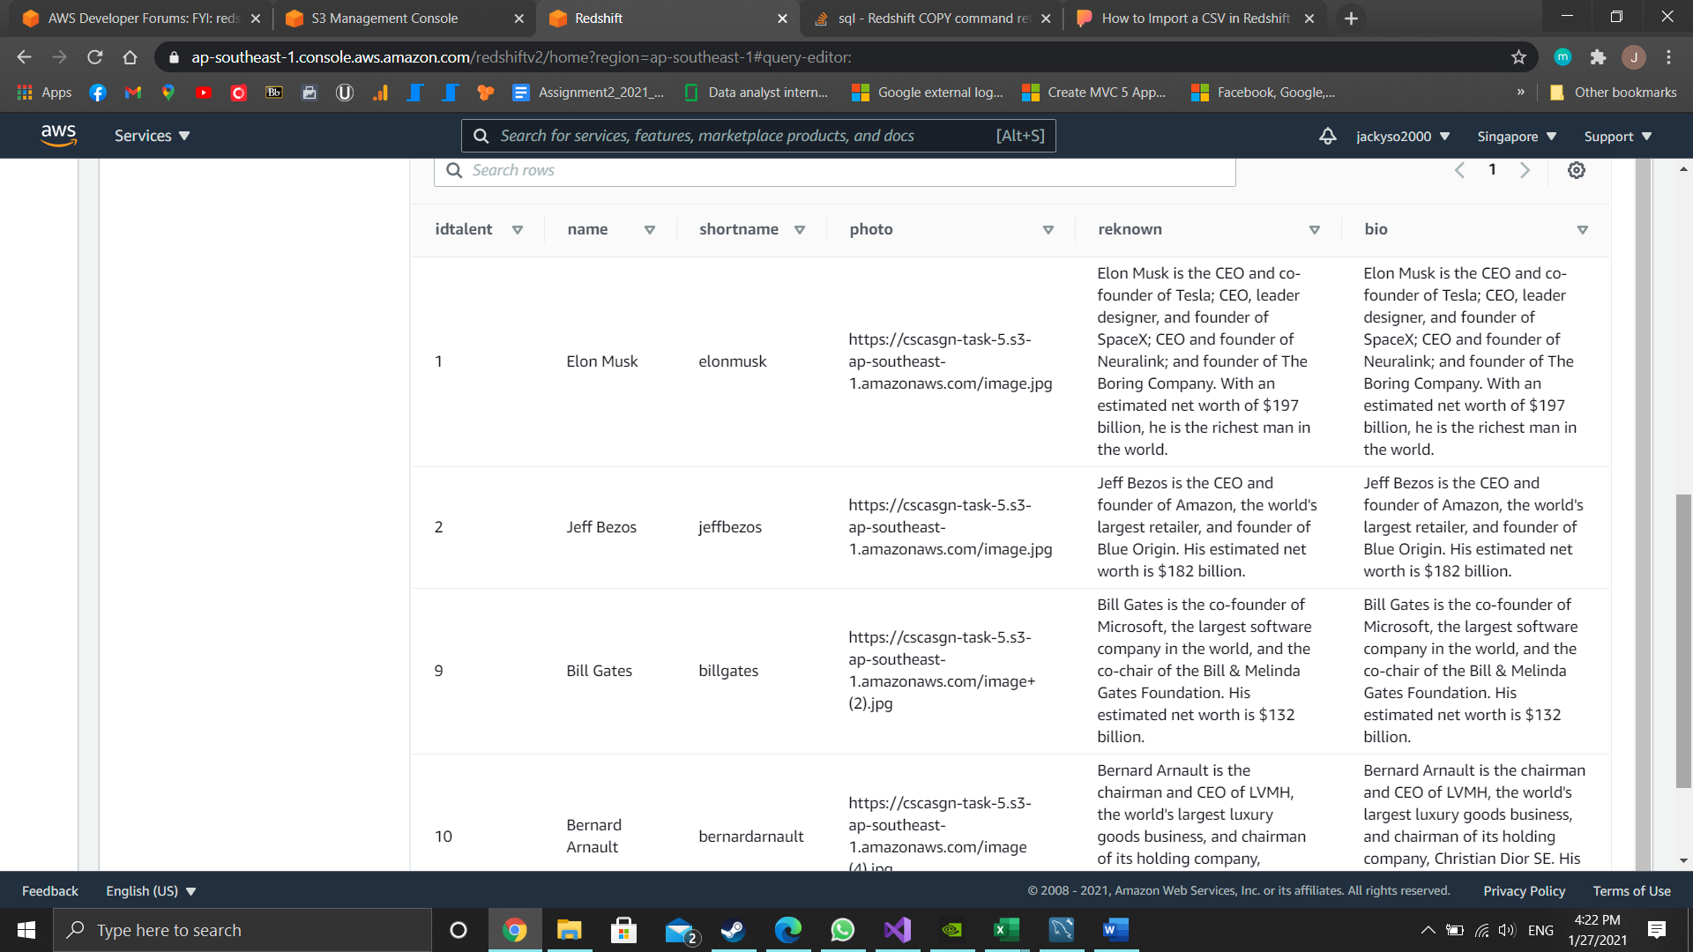

Amazon Cognito

Authenticate user when log in to the web app

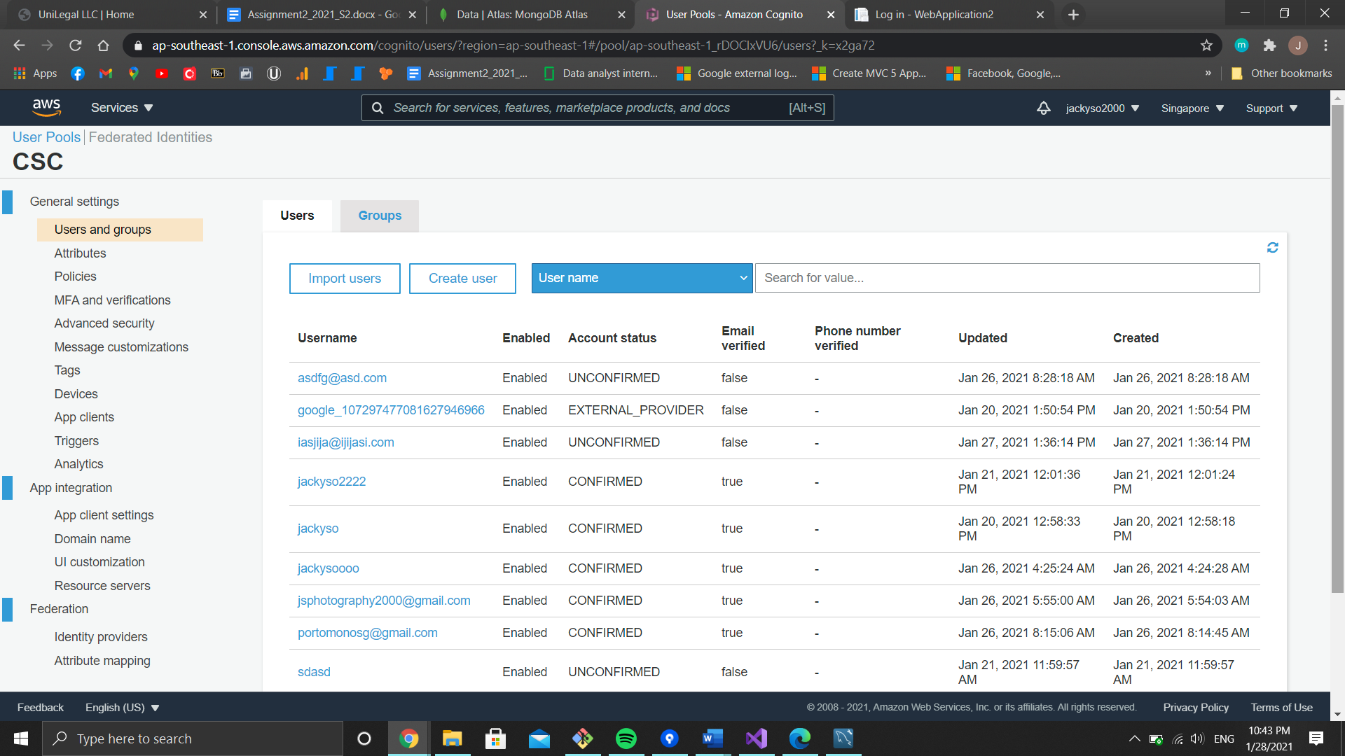

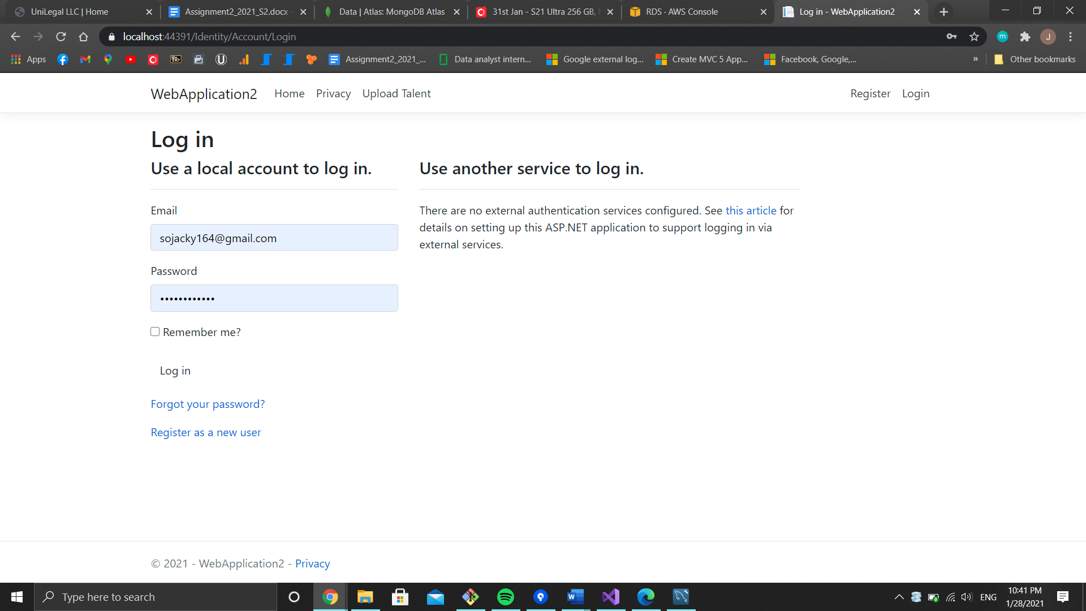

LambdaTest

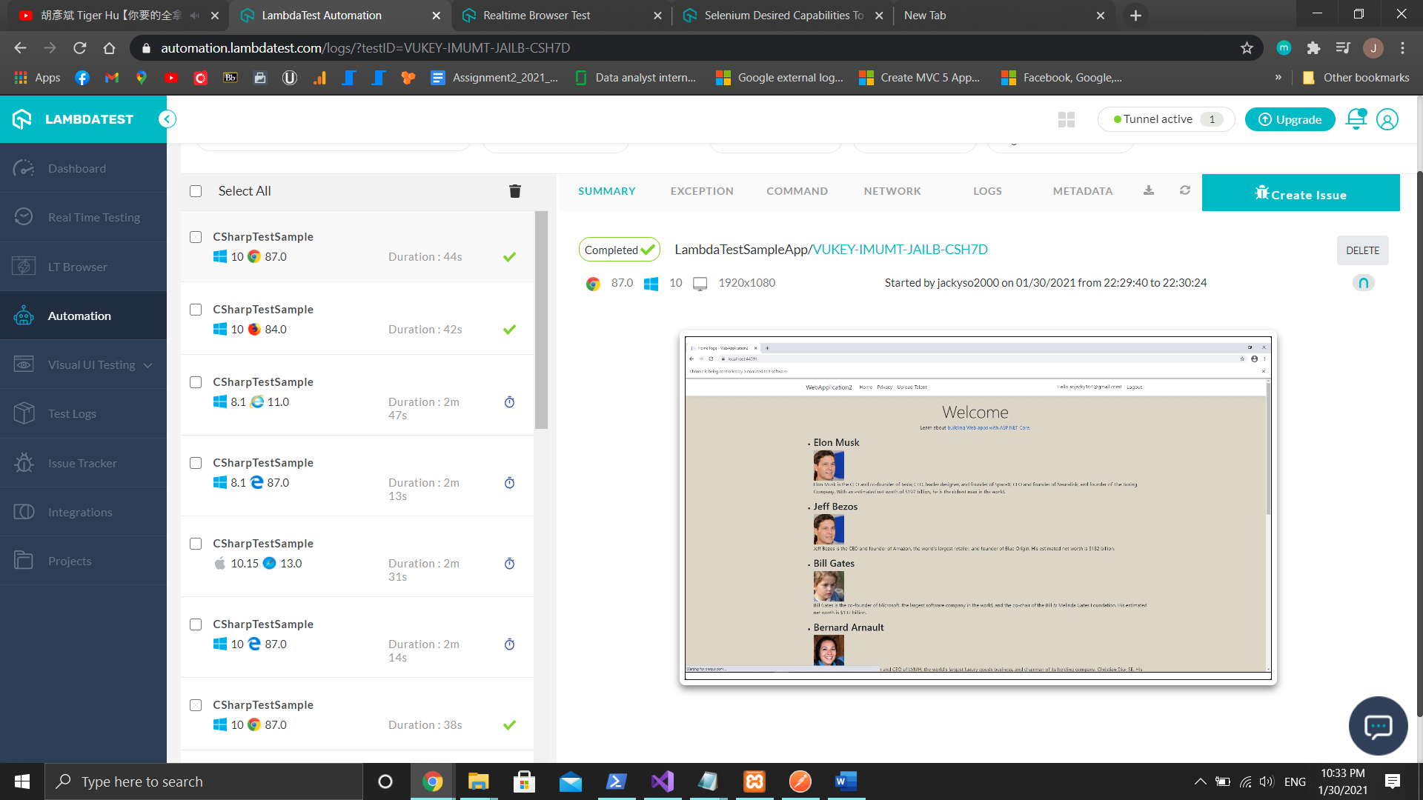

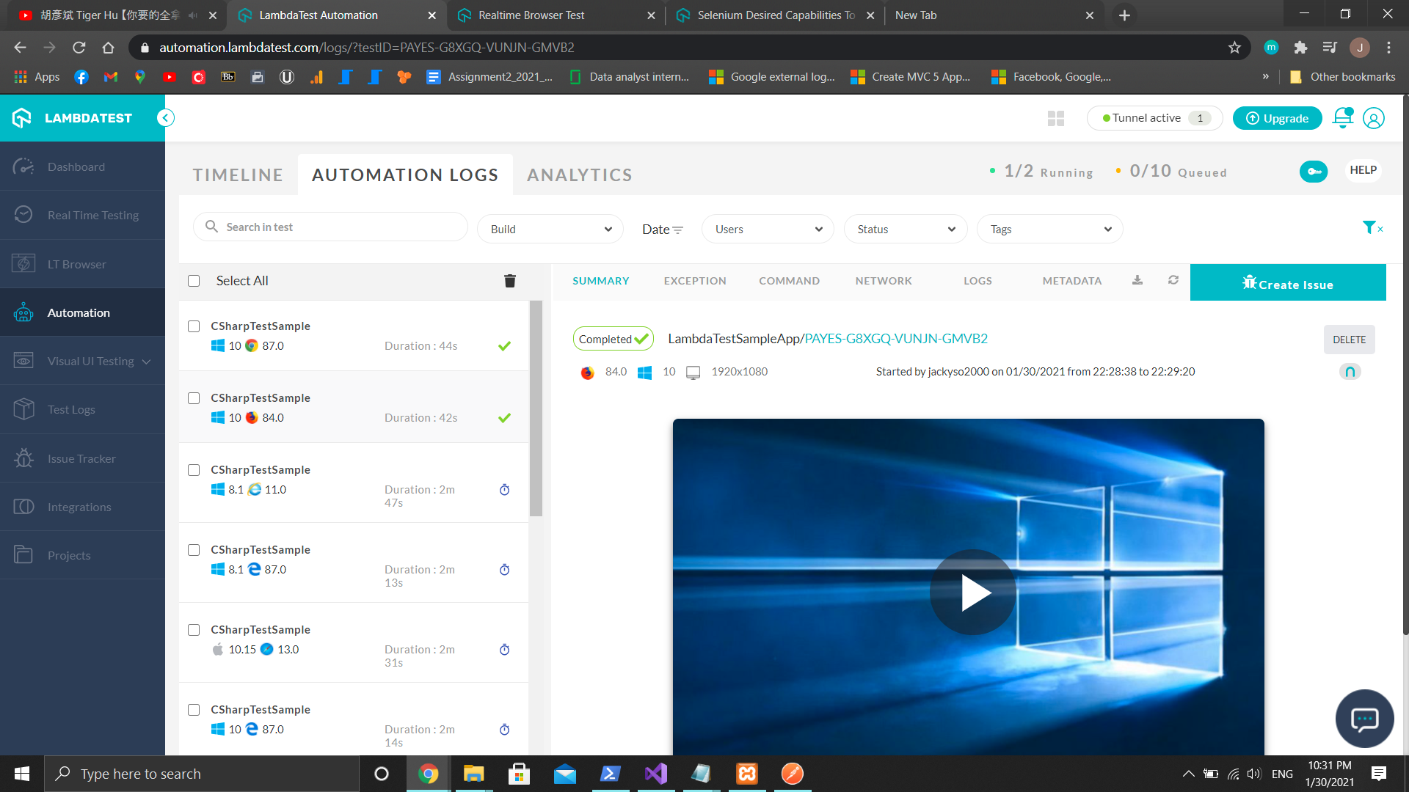

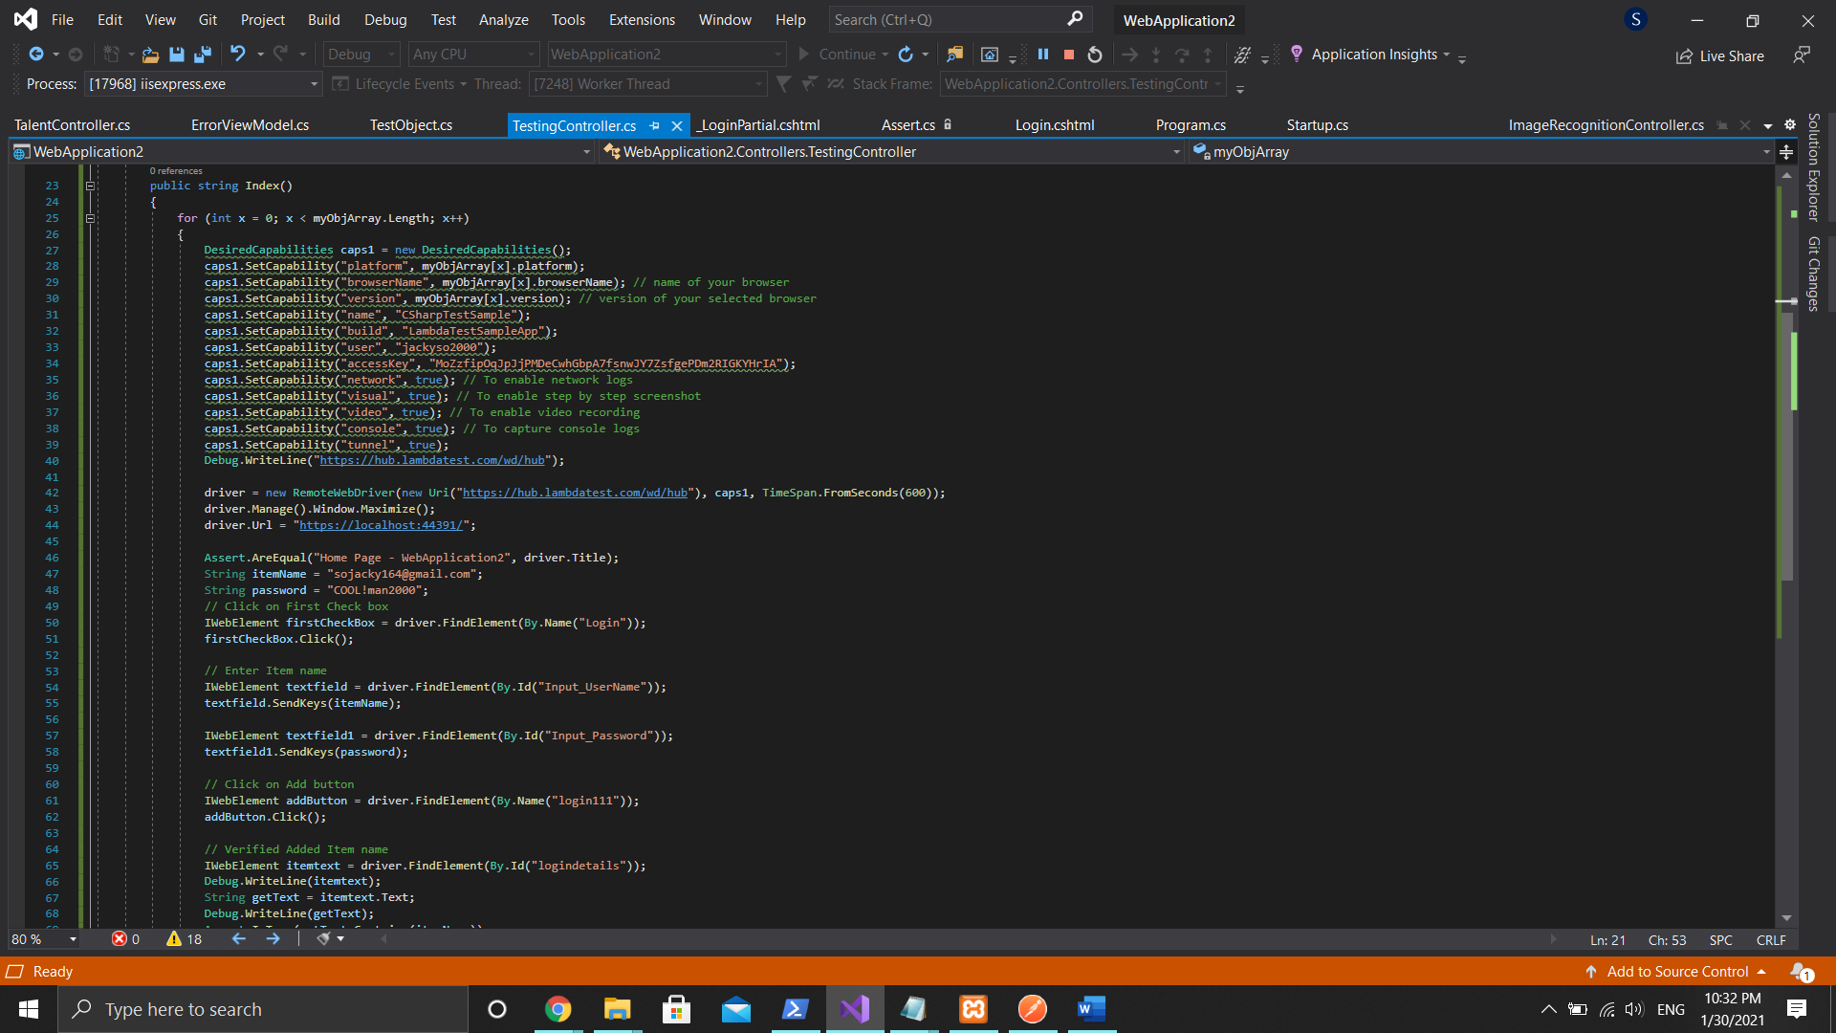

https://{hostname}:{port}/home/gettasks

Get all talent’ details

Return JSON stating id, name, shortname, reknown, bio and photo link

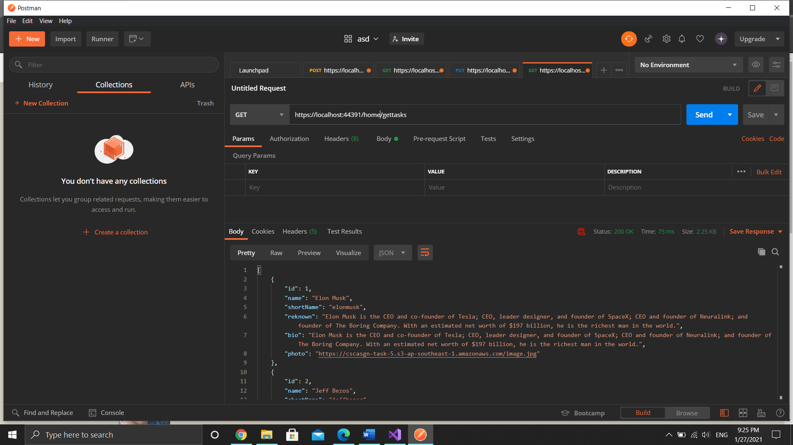

https://{hostname}:{port}/ImageRecognition/ImageRecognition

Check if submitted photo is a human

Return Boolean stating outcome

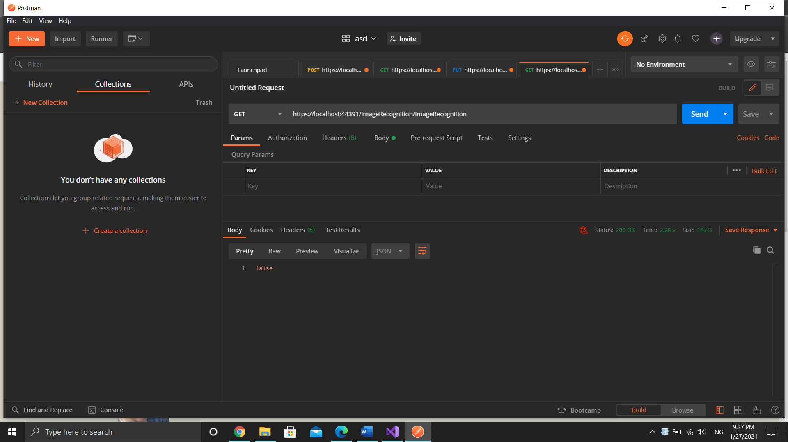

https://{hostname}:{port}/create-checkout-session

Create checkout session on Stripe

Receive checkout session model (CreateCheckoutSessionRequest) from cshtml

Return sessionid when a session is successfully created

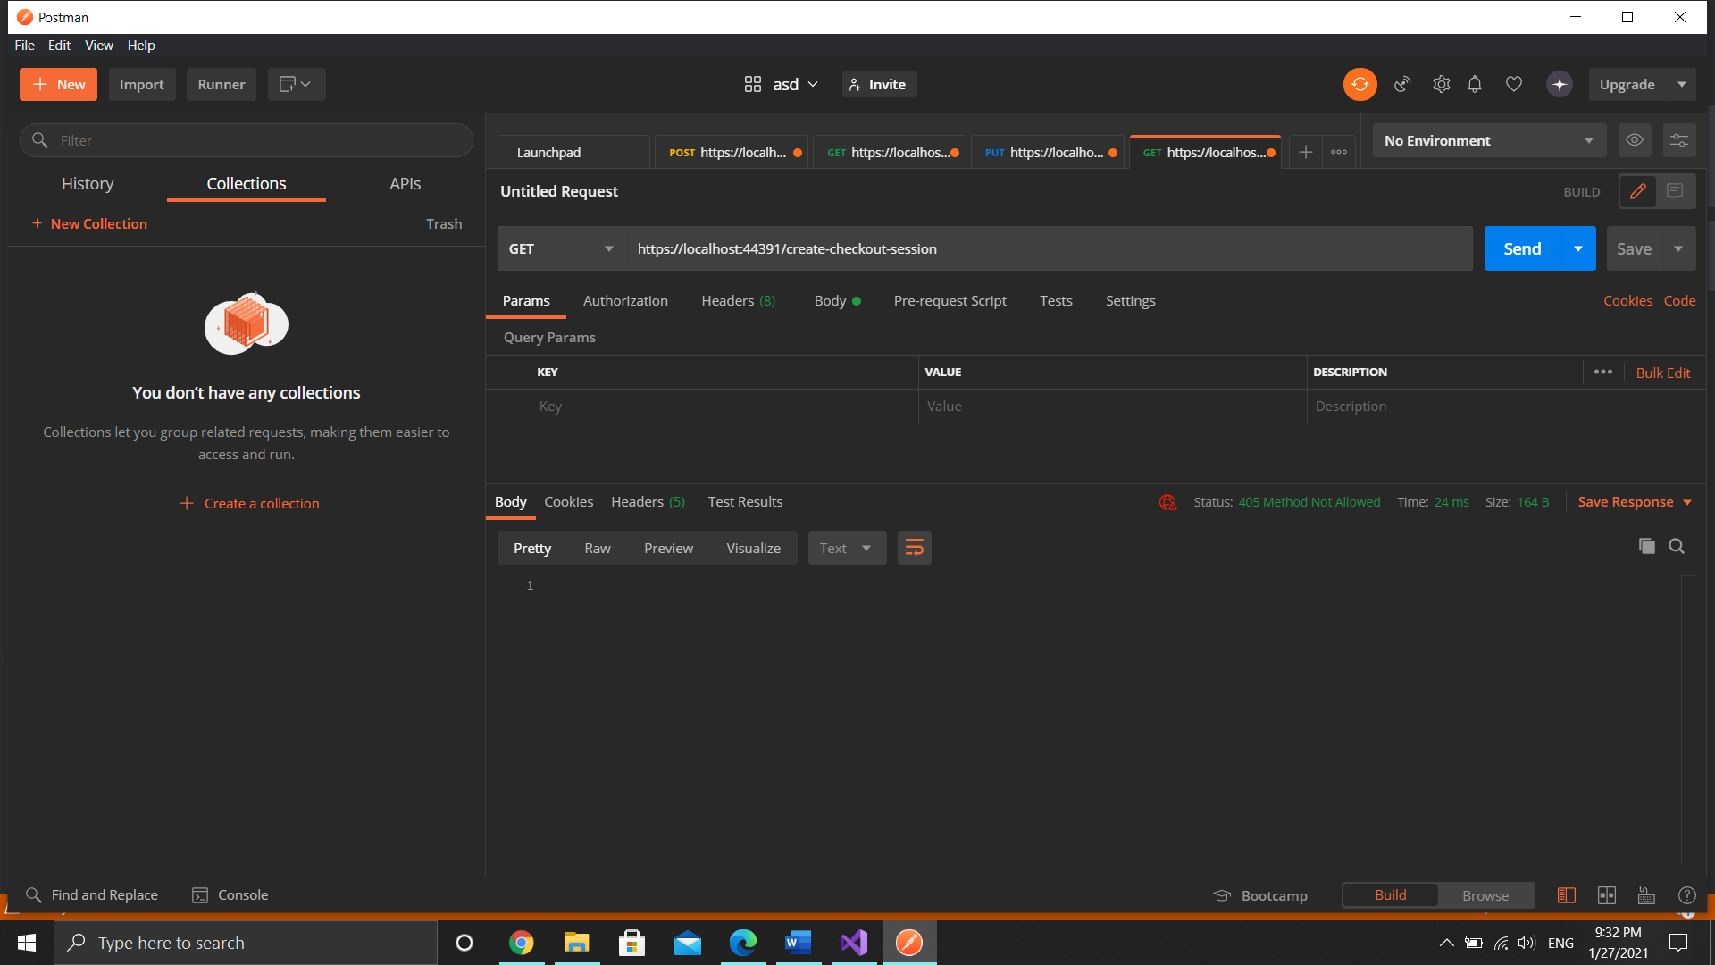

https://{hostname}:{port}/checkout-session

Get session details with session id

Return JSON containing session details

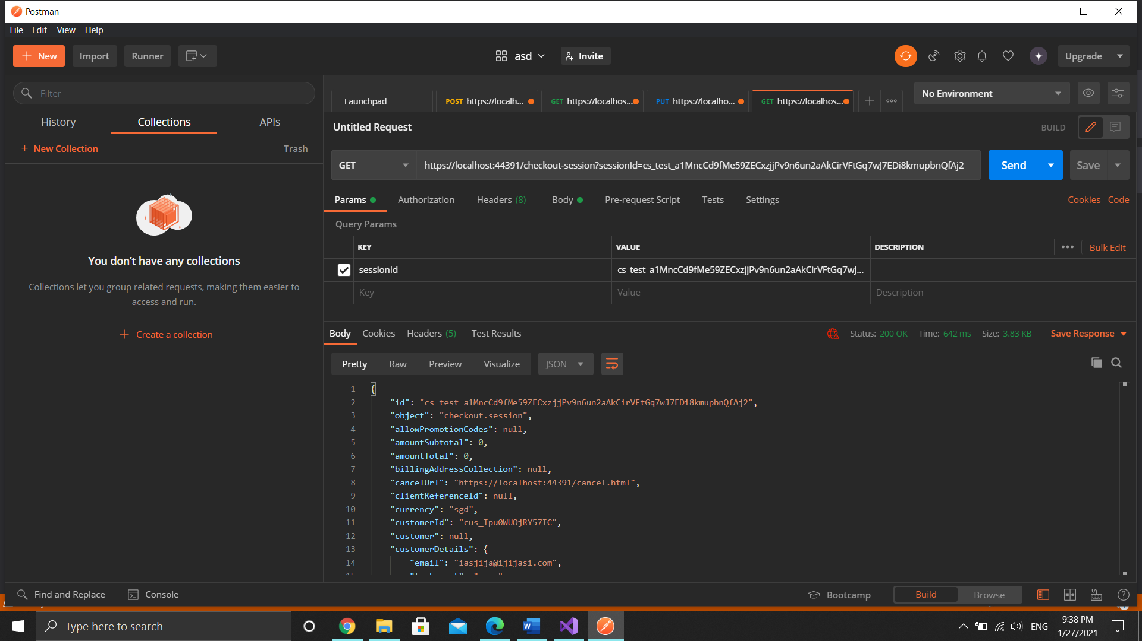

https://{hostname}:{port}/Talent/Upload

Insert new talent record

Return successful message

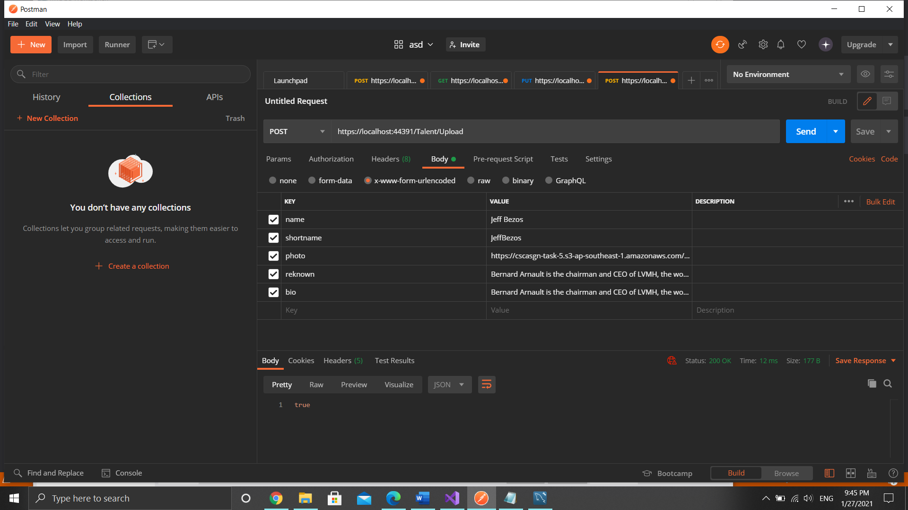

https://{hostname}:{port}/api/userdetails

Get all user details

Return JSON stating id, email, subsID, plan and lastPaid

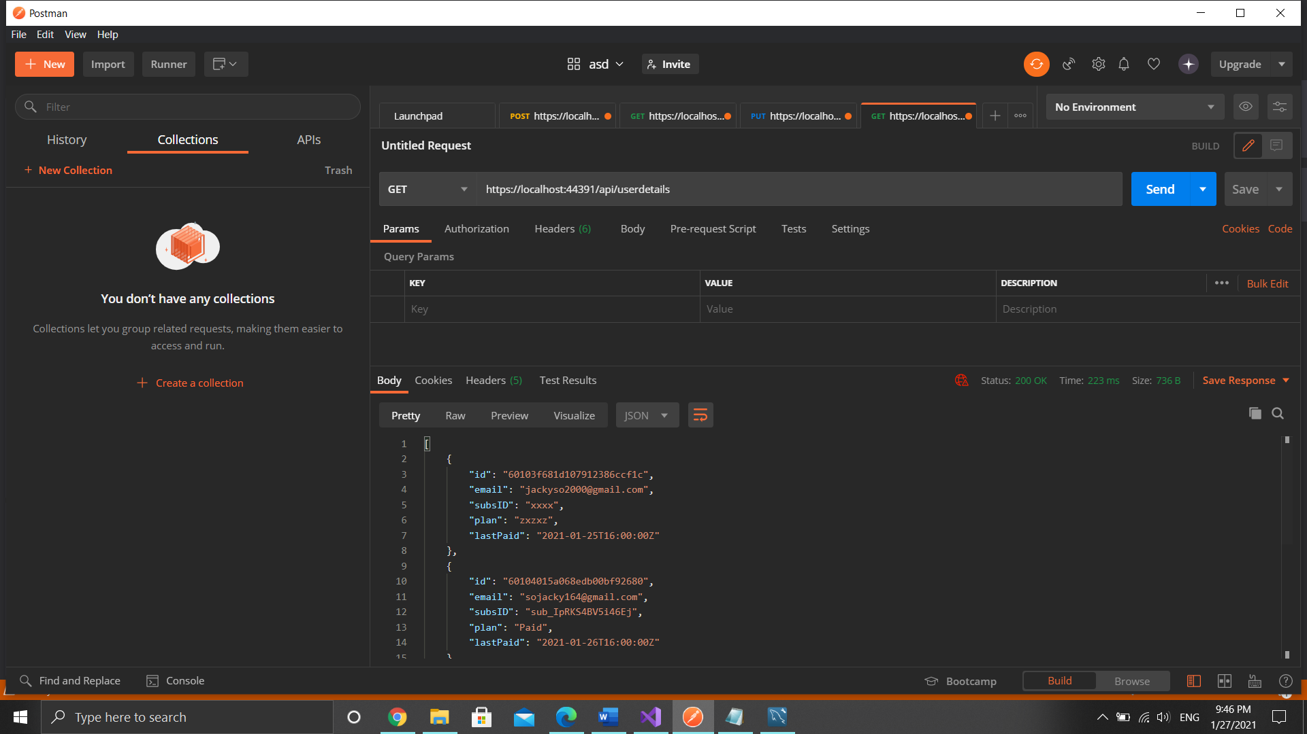

https://{hostname}:{port}/api/userdetails/{email}

Get user details record with email

Post email

Return JSON stating id, email, subsid, plan and lastpaid date.

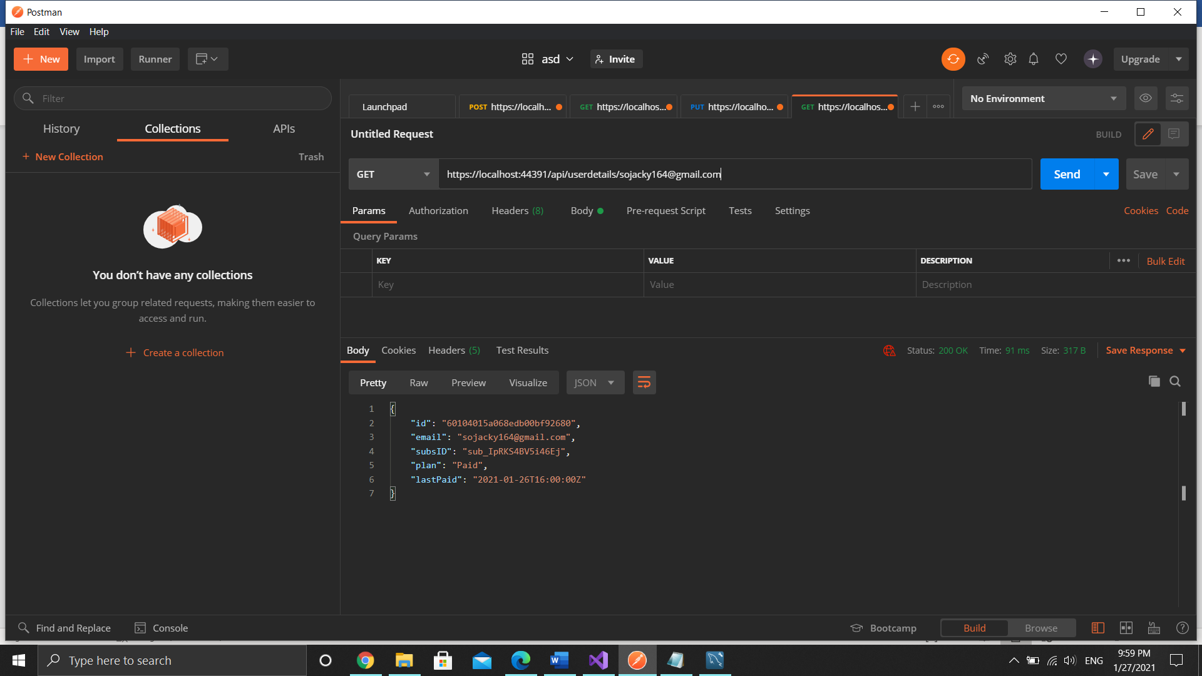

https://{hostname}:{port}/api/userdetails

Create new user details record

Post email, subsID, plan and last paid date

Return JSON stating email, subsID, plan and last paid date that show created

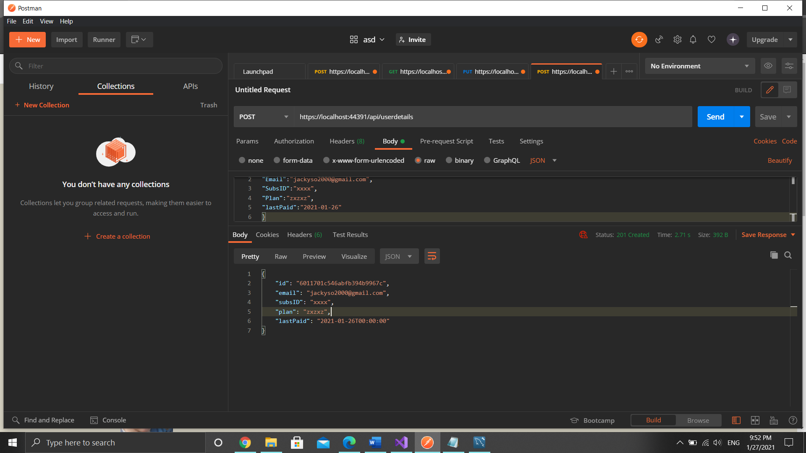

https://{hostname}:{port}/Testing

Create LambdaTest session

Return success message when test is done

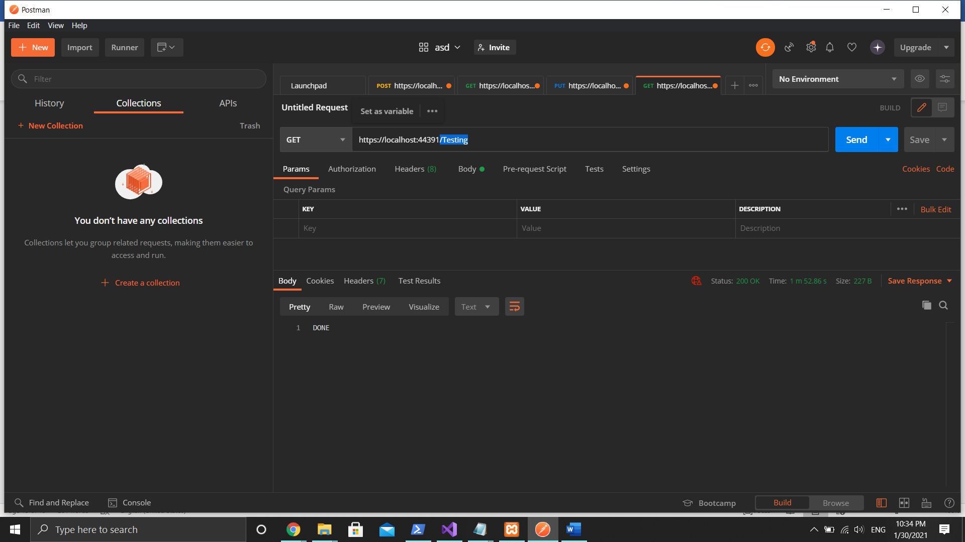

Sequence Diagram

